Design Brief/Technical Document

This is the Design brief for the website for Madroño Nicaraguan Restaurant. It will also cover the elements in the business image designed for this project.

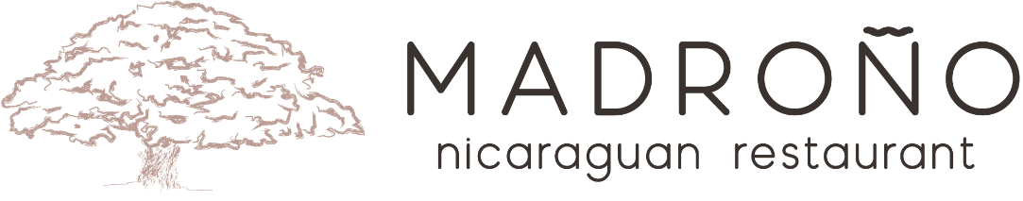

The restaurant logo is conformed of the original tree icon designed for the logo next to the name of the restaurant.

The typographical elements on the logo uses an original retouched version of the free to use font Moon 2.0 both Bold and Regular.

License: <https://www.cufonfonts.com/font/moon-20>

#BC9E94

In the navigational bar, besides the logo, the other list items use a san-serif font, I personally like Helvetica so I decided to called it first followed by sans gill and then just any sans serif font

Color : #BC9E94 for consistency with the logo

color: darkgrey. When it’s hoover on.

#BC9E94

The color in the logo is used across the website for a consistent overall image.

Throughout the website I used two other google fonts listed bellow:

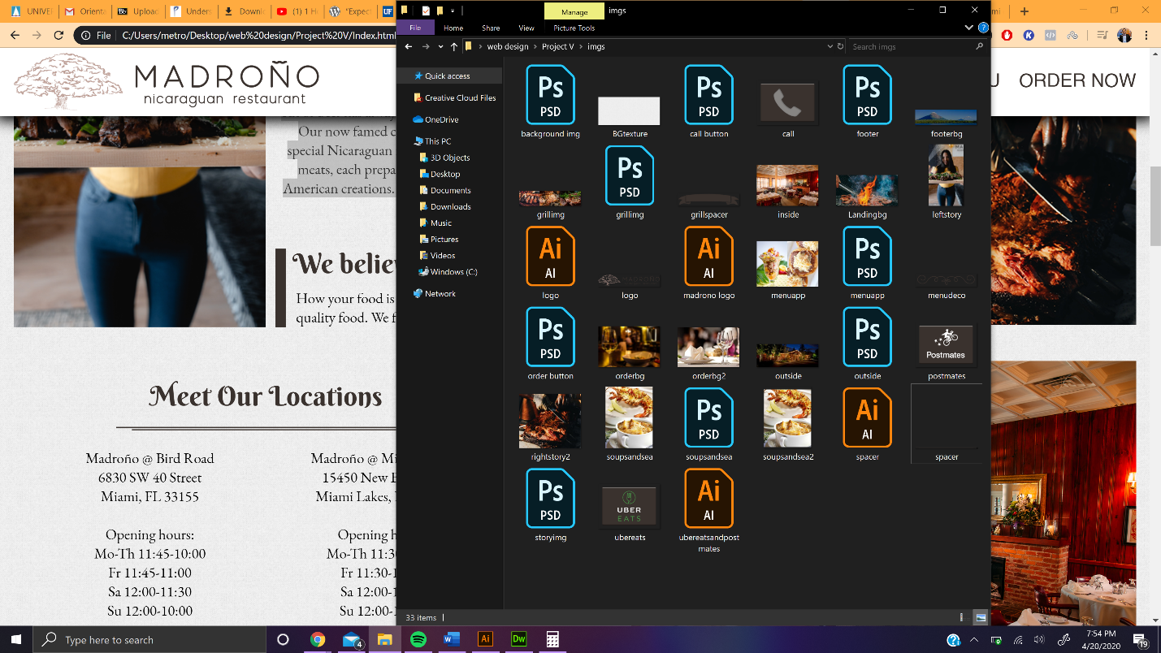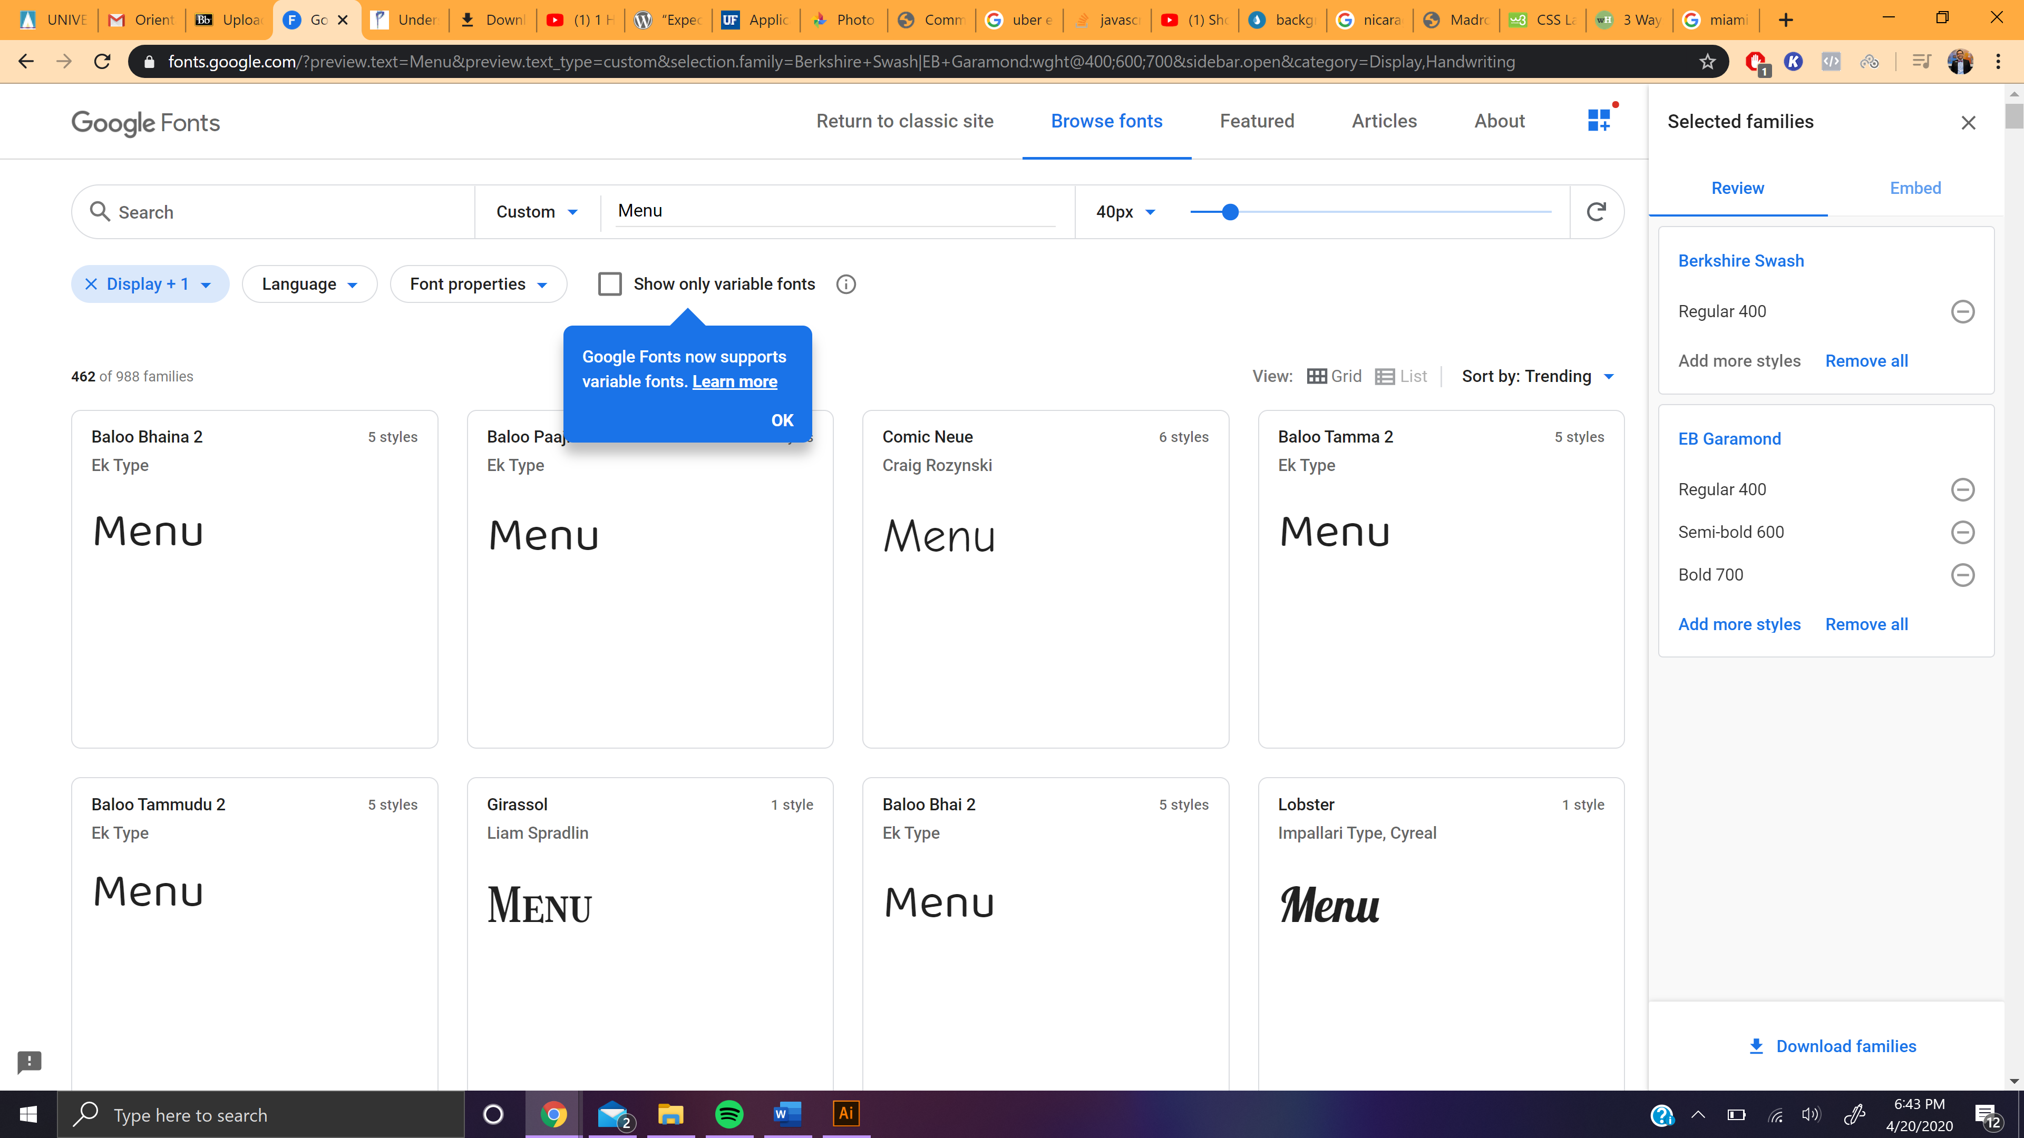

Pictures and assets for the project

As a General rule I used this font on:

Body texts and general headers for the decorative power it offers.

And in the menu for the crisp, for the classy feel it gives.

As a General rule I used this font in all main title header H1 and the decorative typographic element on the landing page.

Always on color: #BC9E94 for consistency with the logo

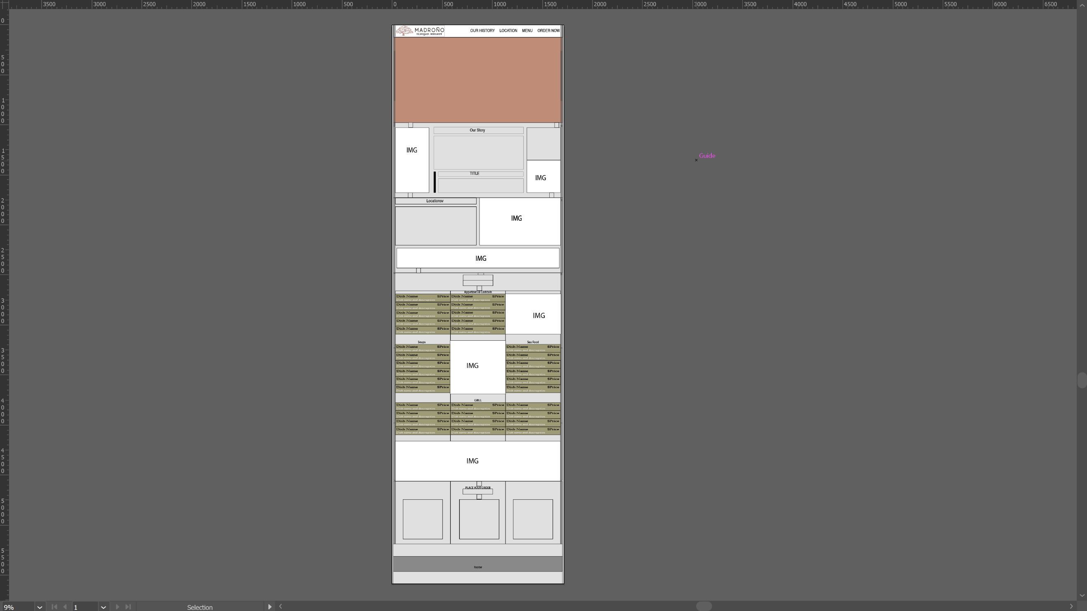

Left and right margin 20px; except on landing page, order now and footer.

Navigational bar 1690px x 100px

Screen width 1690px x 850px

Landing page’s heigh 750px

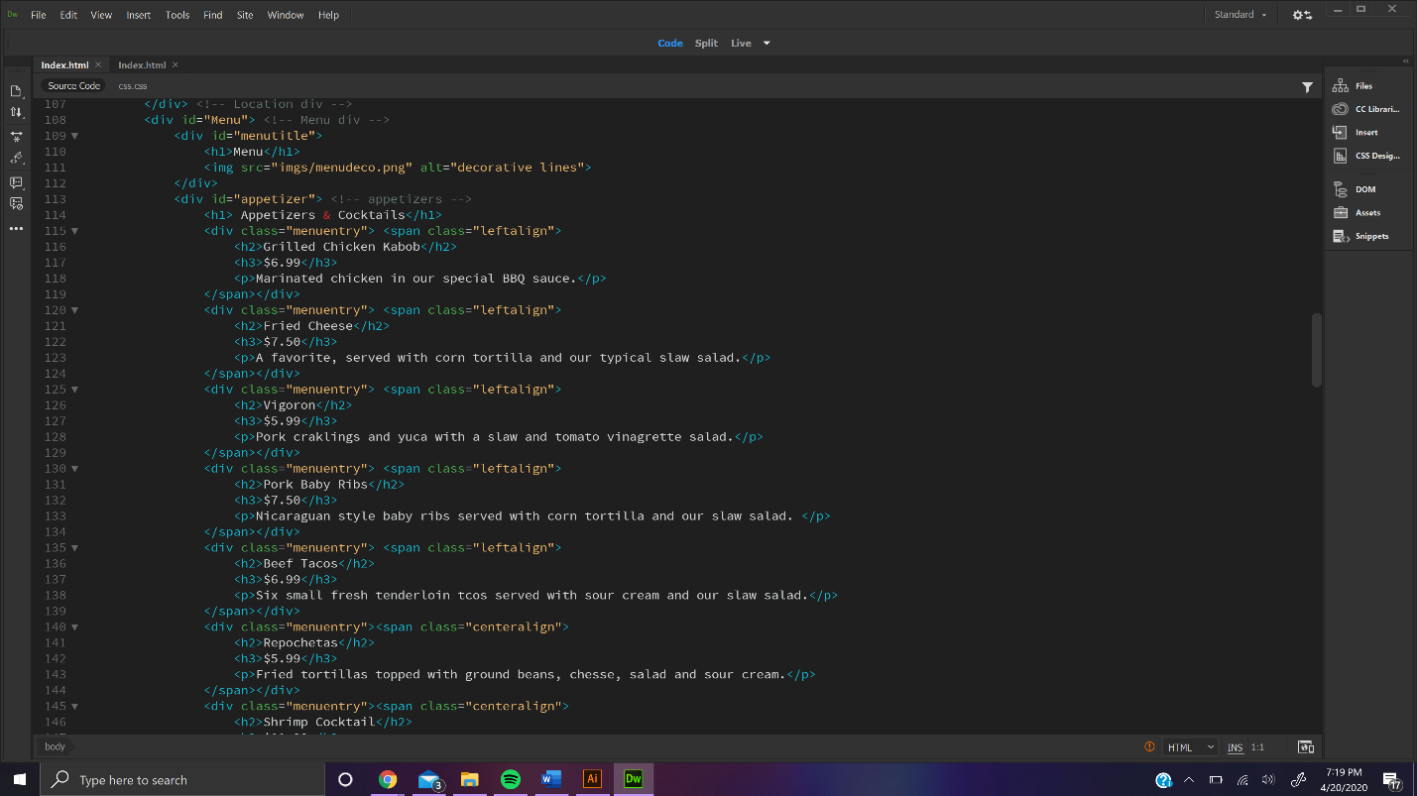

Lowe img height 200px

Top elements 50/50 total width respecting the marging. 500px hegih

Order now screen. Height: 750px

(3) 550px x 400 px buttoms

Footer 400 px & 200px stripe.

Starting on the menu I started using a 3 columns layout.

Menu entry set up hierarchy

Menu’s height 2400px

Our story content’s height 650px. Top and bottom margin 50px

Left and right elements 370 width. Center element 810 width.

Grill images’ height 400px